CREATE TYPE Name1 AS OBJECT(

fname varchar(20),

lname varchar(20)

)final

CREATE TYPE phone_array AS VARRAY(4) OF varchar(15);

CREATE TABLE Author1 (

author_id VARCHAR2(20) PRIMARY KEY,

name1 Name1,

phone_no phone_array

);

INSERT into Author1 VALUES('A1', Name1('John','Cena'), phone_array('0123456789'));

INSERT into Author1 VALUES('A2', Name1('Ron','Doe'), phone_array('0123456789'));

INSERT into Author1 VALUES('A3', Name1('abc','cde'), phone_array('9876543210'));

INSERT into Author1 VALUES('A4', Name1('aum','cde'), phone_array('4567283010'));

DELETE FROM Author1;

SELECT * FROM Author1;

CREATE TYPE Publisher1 AS OBJECT(

pub_id varchar(20),

pub_name varchar(20),

branch varchar(20)

)final

CREATE TYPE author_id_array AS VARRAY(30) OF VARCHAR(20);

create type keyword_set is varray(10) of varchar(10);

CREATE TABLE Book1(

ISBN INTEGER PRIMARY KEY,

title varchar(30),

author_id author_id_array,

category varchar(10),

publisher Publisher1,

keyword keyword_set,

price NUMBER(10,2)

);

INSERT INTO Book1 VALUES (123456, 'The Great Book', author_id_array('A1', 'A3'), 'Fiction', Publisher1('P1','abc','UK'), keyword_set('Adventure', 'Fantasy', 'Epic'), 30.00 );

INSERT INTO Book1 VALUES (423156, 'The Great Love Story', author_id_array('A2', 'A3'), 'Romance', Publisher1('P2','Tata MaGraw Hill','UK'), keyword_set('Adventure', 'Fantasy', 'Epic'), 25.00 );

INSERT INTO Book1 VALUES (745689, 'The ', author_id_array('A1'), 'Fiction', Publisher1('P1','abc','US'), keyword_set('Adventure', 'Horror', 'Epic'), 40.00 );

INSERT INTO Book1 VALUES (124658, 'The hero ', author_id_array('A2', 'A4'), 'Action', Publisher1('P2','Tata MaGraw Hill','LONDON'), keyword_set('Adventure', 'Horror', 'Epic'), 50.00 );

DELETE FROM Book1;

SELECT * FROM Book1;

CREATE TABLE Customer1(

customer_id varchar(10) PRIMARY KEY,

name1 Name1,

phone keyword_set

);

INSERT INTO Customer1 VALUES('C1',Name1('Prathamesh','Bille'),keyword_set('2456123'));

INSERT INTO Customer1 VALUES('C2',Name1('Pratham','Bille'),keyword_set('5426157'));

INSERT INTO Customer1 VALUES('C3',Name1('Prath','Bille'),keyword_set('3456125'));

INSERT INTO Customer1 VALUES('C4',Name1('Pra','Bil'),keyword_set('3456125'));

SELECT * FROM Customer1;

CREATE TABLE Book_Sale(

sale_id varchar(10) PRIMARY KEY,

customer_id varchar(10),

ISBN INTEGER,

FOREIGN KEY (customer_id) REFERENCES Customer1 (customer_id),

FOREIGN KEY (ISBN) REFERENCES Book1 (ISBN)

);

INSERT INTO Book_Sale VALUES('S1','C1', 123456);

INSERT INTO Book_Sale VALUES('S2','C2', 423156);

INSERT INTO Book_Sale VALUES('S3','C3', 745689);

INSERT INTO Book_Sale VALUES('S4','C4', 124658);

DELETE FROM Book_Sale;

SELECT * FROM Book_Sale;

1. List all titles in “book” and include ISBN, author name (as combined from author.fname and author.lname).

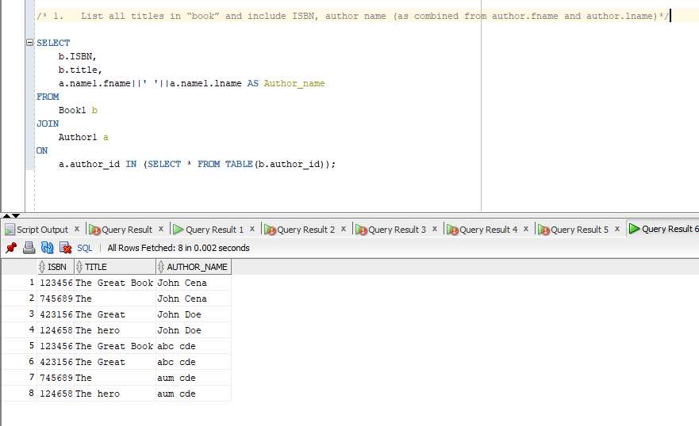

2.List all customers who have purchased books published with ‘Tata MaGraw Hill’.



3.List customers (as combined from customer.fname and customer.lname) who have purchased books published in the UK or the US, as well as the title of the book they purchased and the name of its publisher and order by last name of customer.

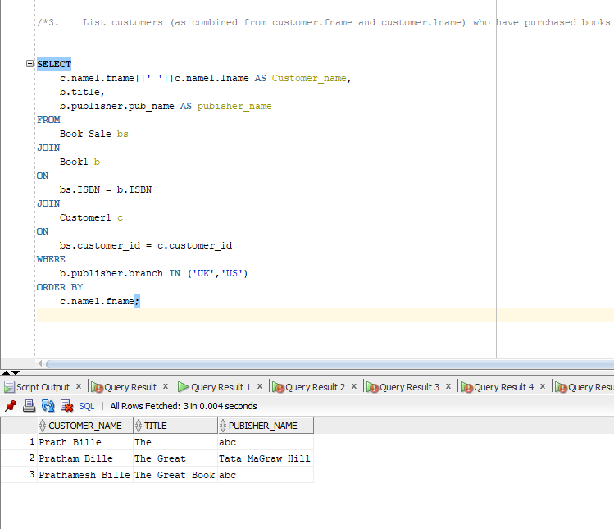

4.List the different (distinct) categories and how many books belong to each category, order alphabetically by category.

5.List the number of books sold that have been written by each author and group by author’s first name.

